**Lesson3 APP7:**

**Delete an EBS Volume**

**Selecting the EBS volume you want to delete:**

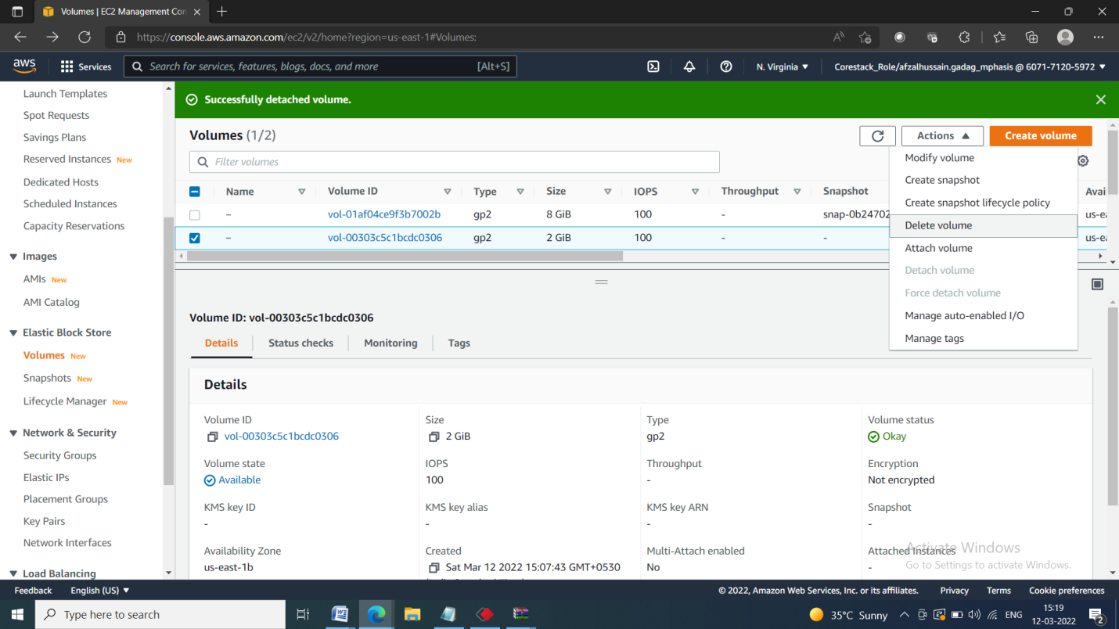

**Deleting the volume:**

